SAM Safety Seal
Guedel
The SAM Safety Seal is designed to be used together with
the SAM Guedel during bag mask ventilation with bearded,
misshapen face and denture-less patients to assist in
providing a better seal. The device is also used with any
patient where aerosolisation of patient secretions during bag
mask ventilation is a concern.
The device is easy to use. Simply invert the SAM Safety Seal
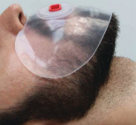
wings into a gloved hand and place the guedel as per standard
practice. Once the guedel is in situ, release the wings so that
they lay onto the patient’s face.
Once the bag mask ventilation process is completed, simply
grab hold of the SAM Safety Seal wings and fold around the
guedel into your gloved hand and discard into an appropriate
receptacle.
Scan the QR Code to watch a video on how to use the SAM
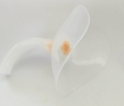
Safety Seal products.
Product Specifications
Silicone - NON Latex Silicone Variant thickness - 1.5-2.5mm
Body Height 2cm Wing Dimensions 17cmx10cm
SINGLE USE ONLY SAM SAFETY SEAL ARTG 331 999
SAM GUEDEL AIRWAY ARTG 353 530
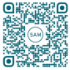
Product Product Order Code Quantity
SAM Safety Seal Guedel 9cm (Yellow) SSSGN09 50
SAM Safety Seal Guedel 10cm (Red) SSSGN10 50
Suzanne Privot
BRINGING INNOVATION TO THE MEDICAL INDUSTRY
DISTRIBUTOR NSW/ACT +61 418 963 351
suzanne@maps2medical.com

